**System Maintenance Documentation**

Forms

|  |  |
| --- | --- |
| Form name | Use |
| FrmMain | It is used to display the data in the system and allows for data manipulation |
| FrmInput | It is used to input new data to the system |

FrmMain Objects

|  |  |  |
| --- | --- | --- |
| Text Object | Label | Shows text that users can use for themself |
| Image Object | Label | Shows images for users and this images help to users take new knowledge or understand information better |
| Page Object | Label | Systemize all information by type of information and make work with website for users easer and more useful |

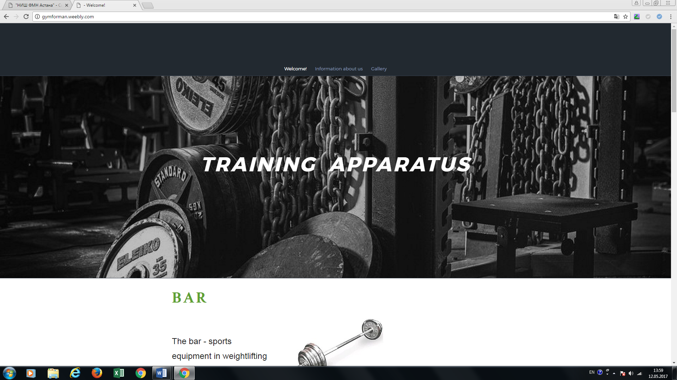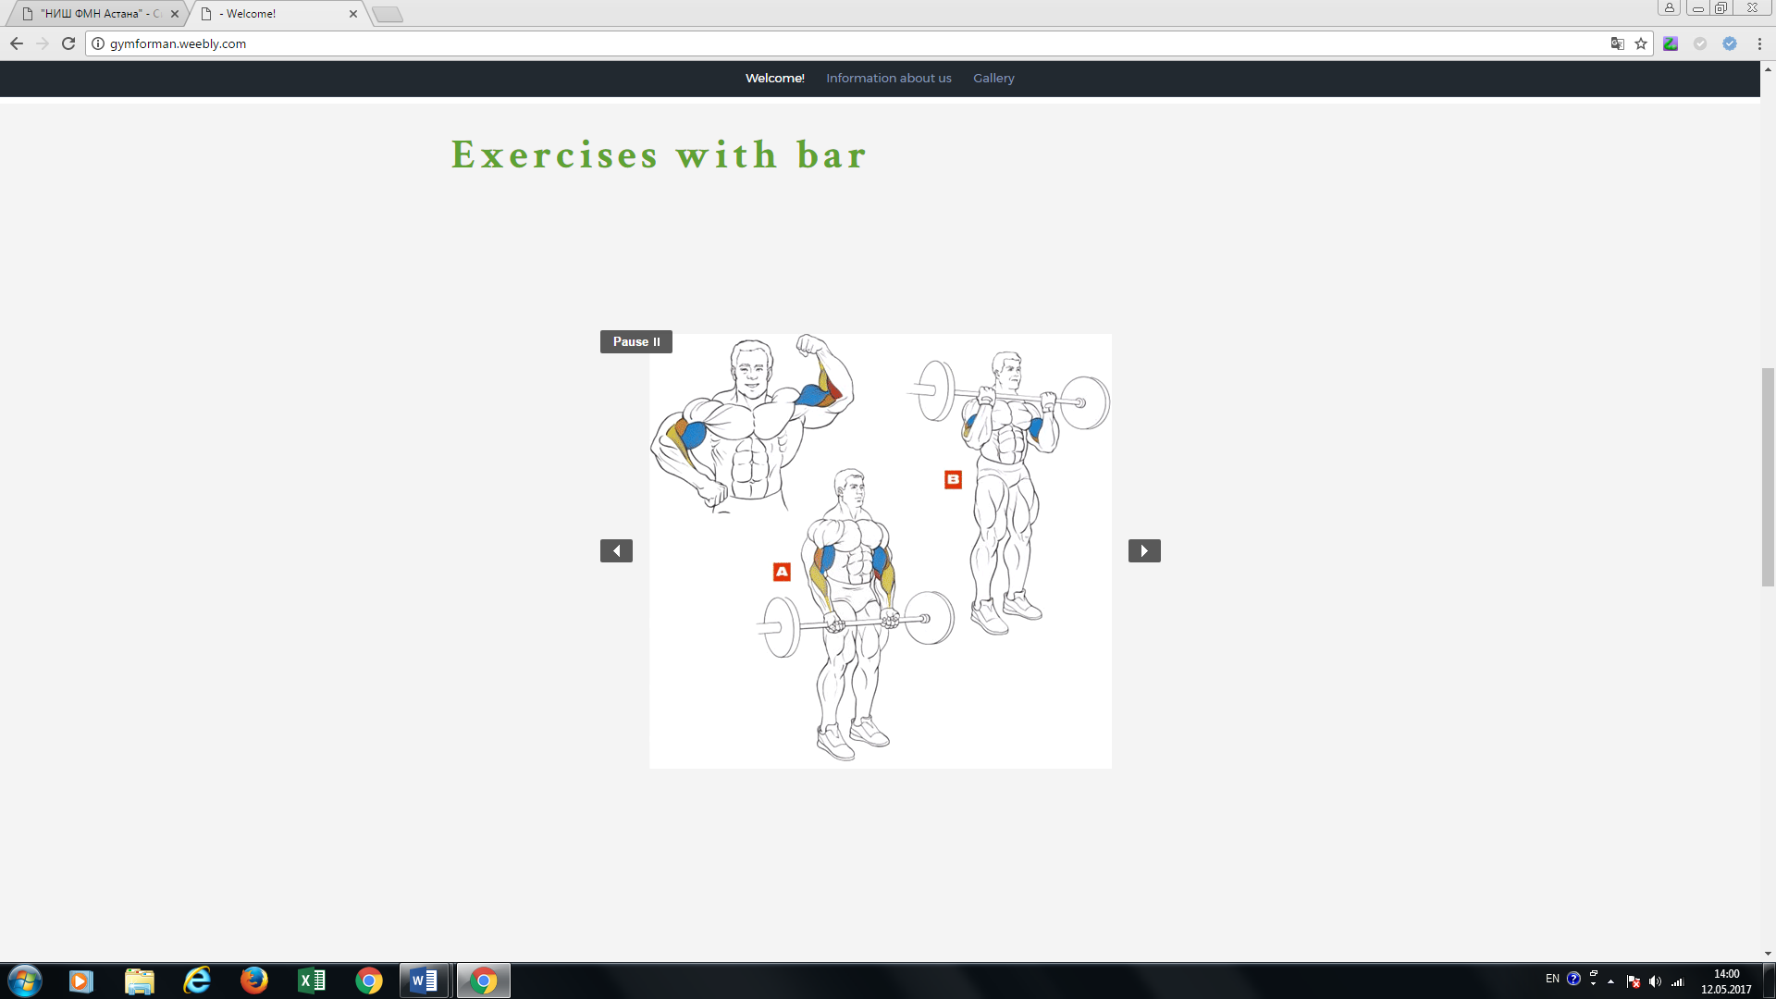

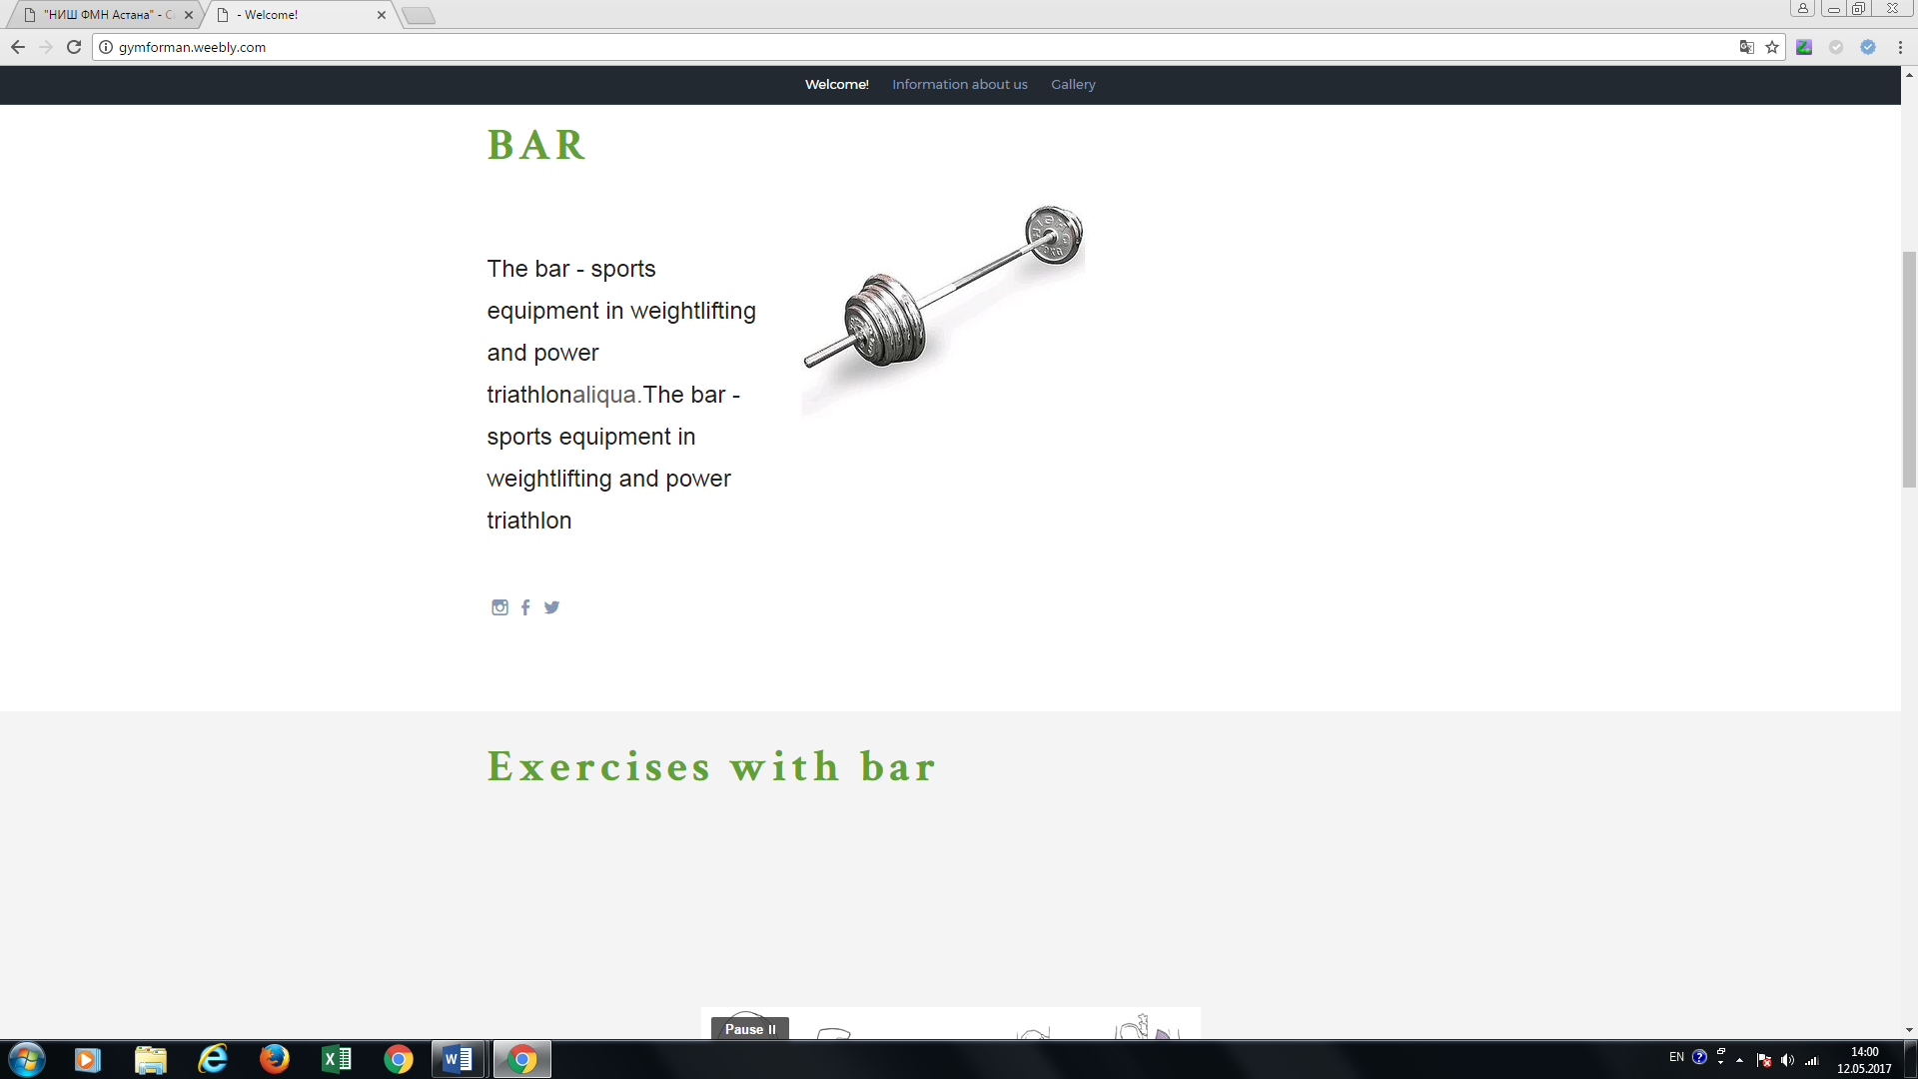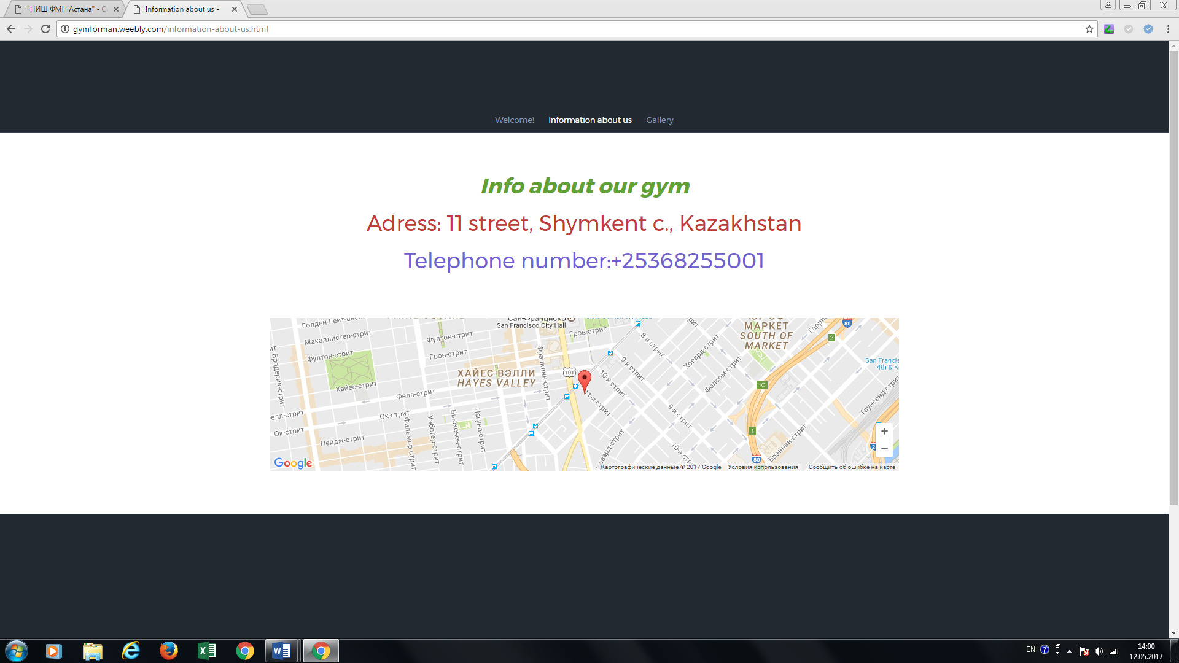

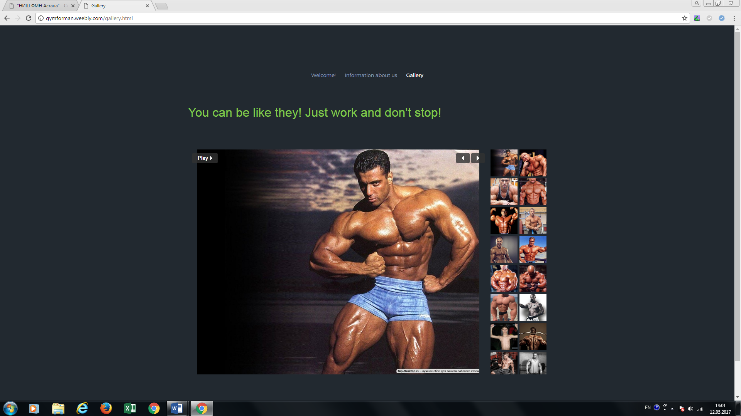

**Website very easy to understand, because interface gives possibility to learn using website. There are 3 pages:**

**First page has main information and some instructions to using sport equipment**

**Second page about information of our shop. There are address, telephone and map image. The main reason of making this page it’s give way to contact us**

**Third page just image with our users and famous sportsmen that motivate our users to buy our items.**